**CSCI 41 – Introduction to Data Structures:**

**Analysis:** After completing each program and running them, I can see that the execution times varied from each sorting algorithms. It can be seen that the Question 4b algorithm, which uses Heapsort is seen to be the fastest among all (please refer to the Excel document).

**Screenshots Output Examples:**

**Question 1 – Shell Sort**

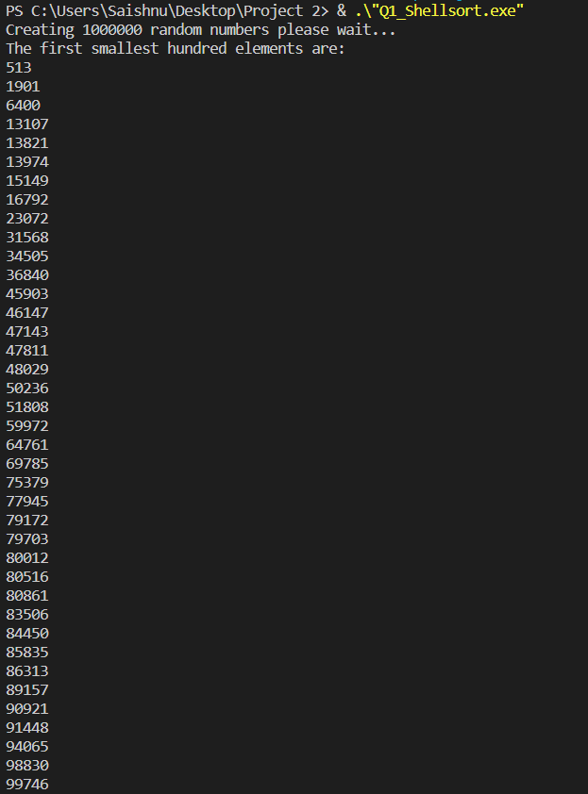

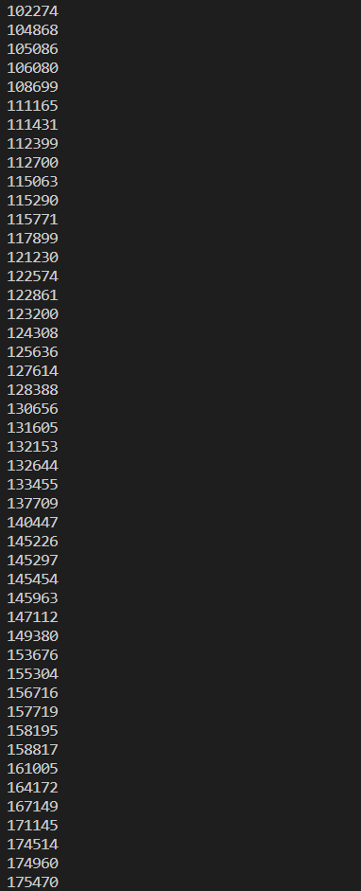

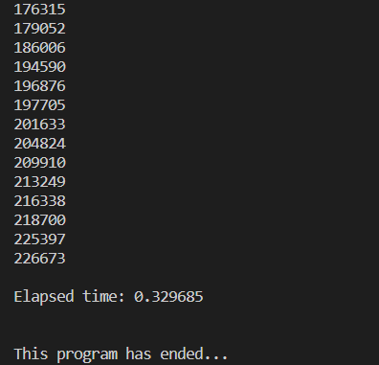

**Question 2 – Quick Sort**

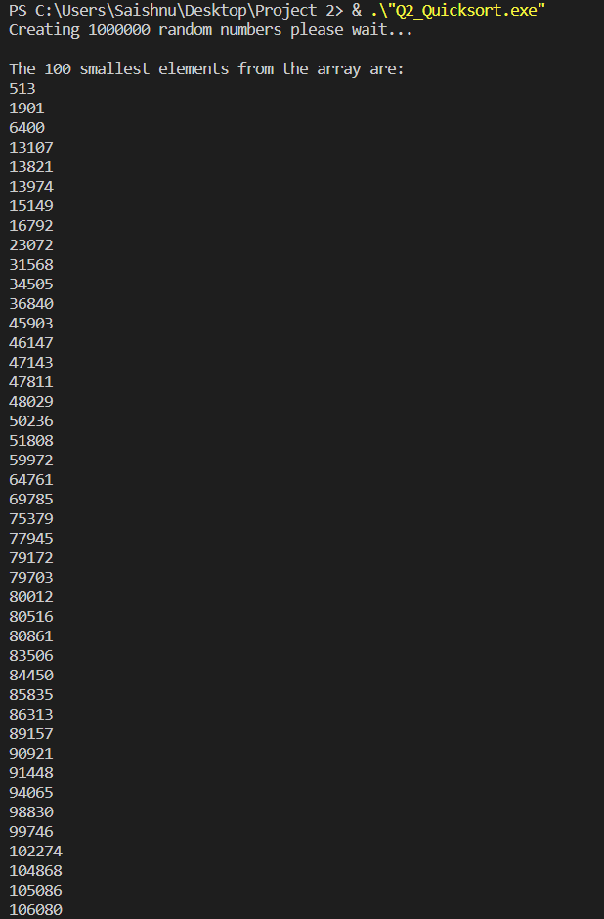

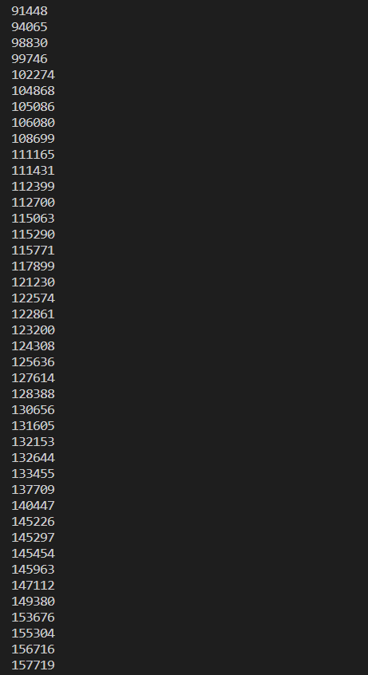

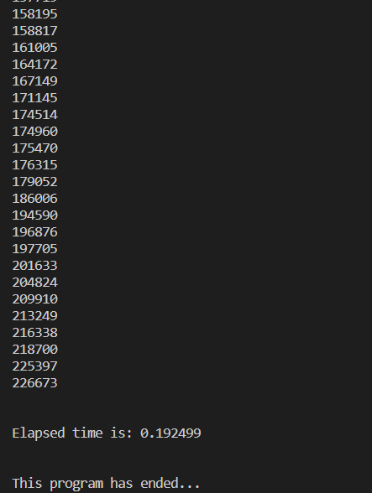

**Question 3 – Dijkstra 3-way partition**

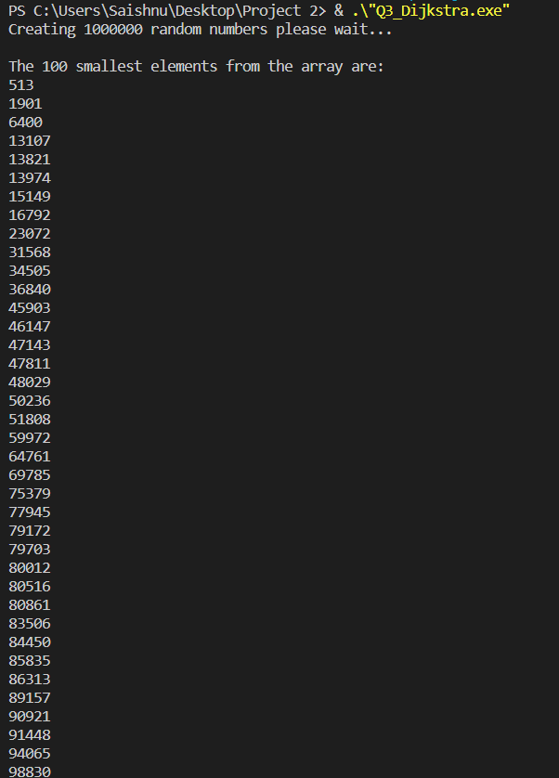

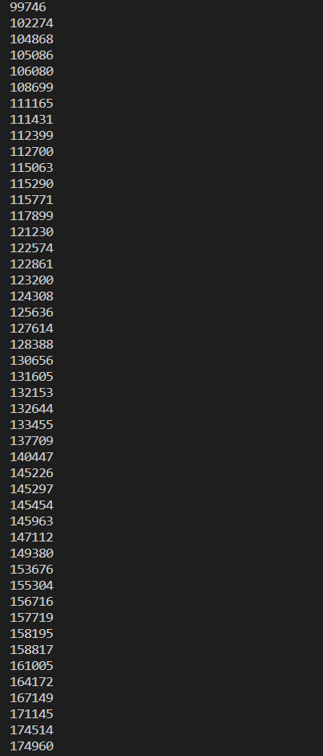

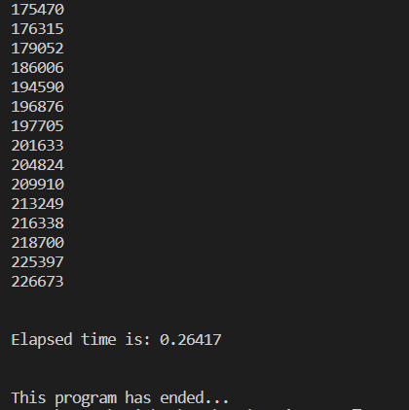

**Question 4a – Priority Queue using Ordered Array/Vector**

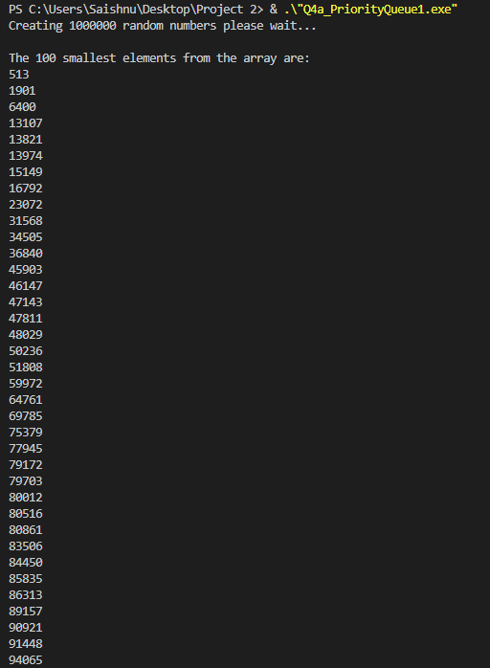

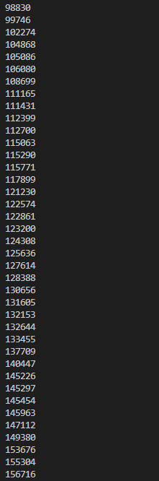

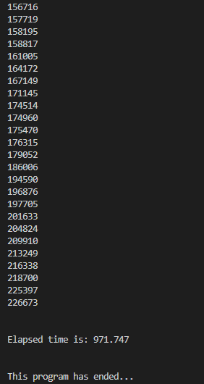

**Question 4b – Priority Queue using Heap using Array/Vector**

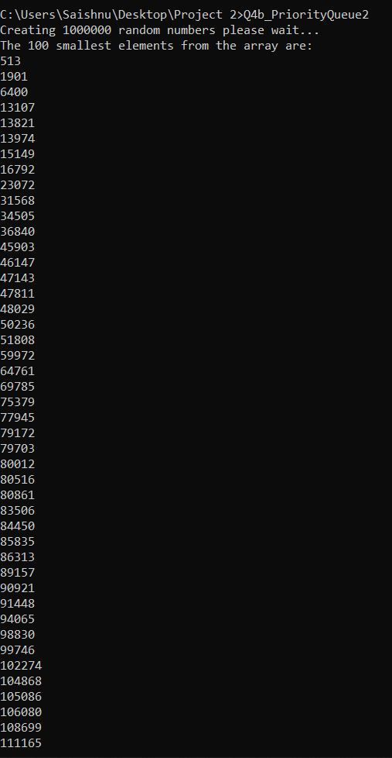

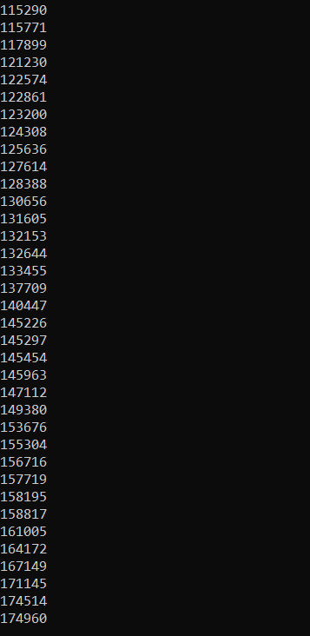

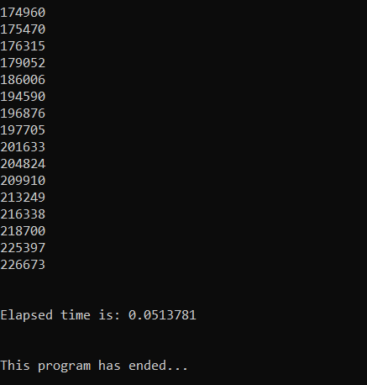

**Question 4c – Priority Queue using Heap using Binary Tree**

